CMPS 312– Fall 2025
Lab Midterm Exam (Duration 2h)
Class Manager App
Develop the ClassManager App using Flutter to enable instructors to manage their classes and students efficiently.
Your app should follow the clean architecture and make use of the Flutter features and packages covered in class It must implement state management using Riverpod Providers and handle navigation with GoRouter. The user interface should make use of essential Flutter UI components such as GridView, ListView, TextFields, Dropdowns, and DatePickers to create a clear and responsive design. For data handling, the app should store data in memory using lists, with the option to integrate a local database for advanced functionality.
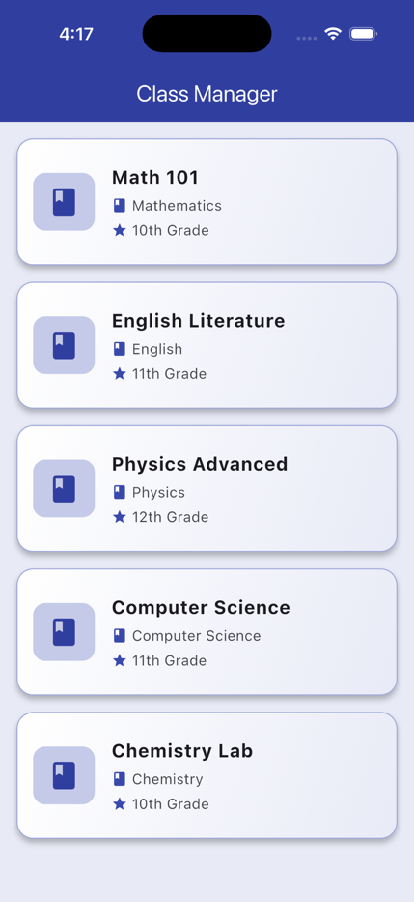 | 1. Dashboard Screen [40 points]: The List Screen displays all available classes in a clean grid or list layout, allowing users to easily browse their travel plans.  When a class card is tapped, the app should navigate to the Students by Class screen to display all students enrolled in that specific class.  Design and Structure Requirements:  App Design: You must design your app screens to exactly match the provided figures and adhere to the style of the app demonstrated at the beginning of the exam.  Project Structure: Strictly follow the structure of the provided base project and write your code inside the provided files and follow the todos.
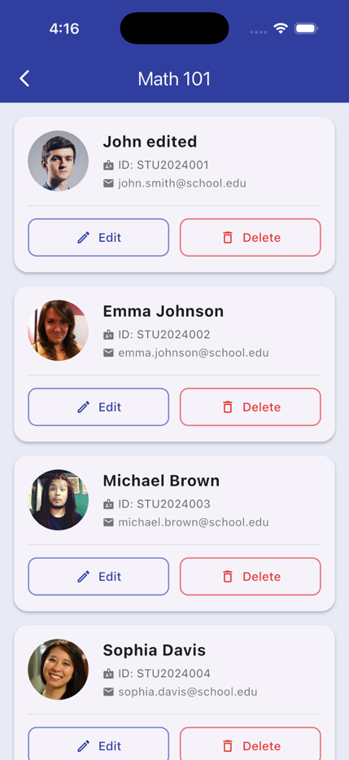 | 2. Student Class Screen [25 Points]: The Students by Class Screen displays all students enrolled in a selected class. When the user taps on a class from the dashboard, the app should navigate to this screen, showing the class name at the top and a list of students below.  Each student card must provide two action buttons: Edit and Delete. The Edit button navigates to the Add/Edit Student screen for updating student details, while the Delete button removes the selected student from the database.  Each student card should display the student's profile picture, name, student ID, and email address, presented in a clean and readable layout using cards or containers.  The design should follow the app's theme, maintaining consistent colors and spacing. Ensure the student list updates automatically after deletion using Riverpod state management.
3. Edit Student Screen [35]: The Edit Student screen allows users to modify the details of an existing student. The form should display the current values pre-filled in the input fields to make editing simple and intuitive. Users can update the Student Name, Student ID, Email, and Profile URL .
Once changes are made, clicking the Save button to update the existing student and immediately refresh the student list using Riverpod state management.
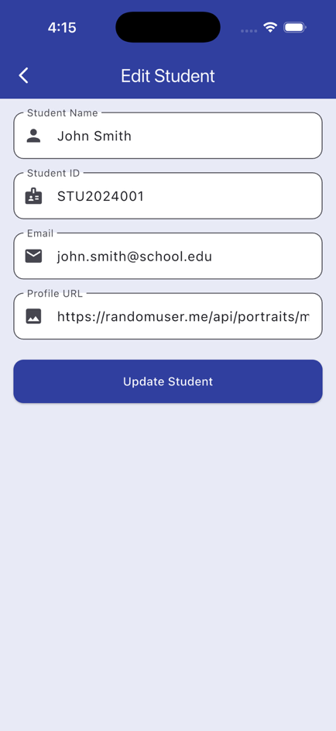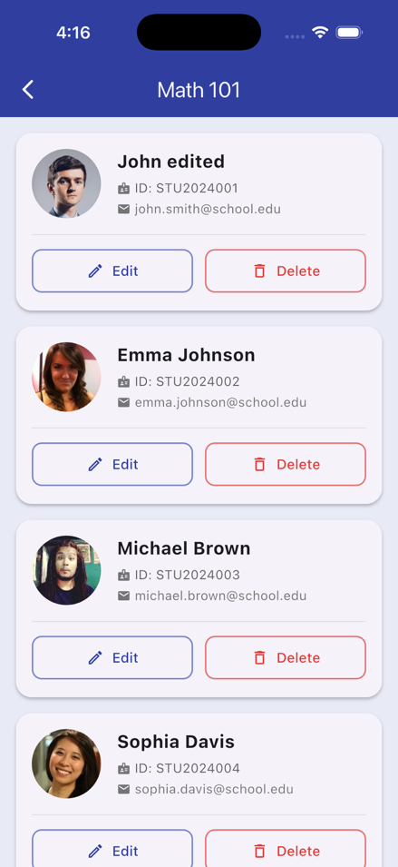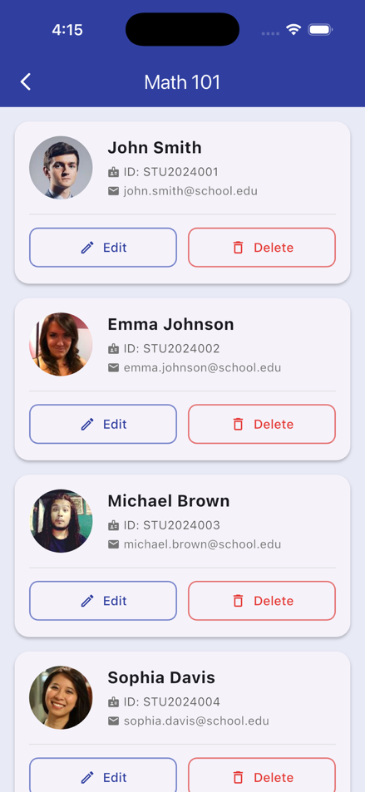

1

Criteria | % | Quality of the implementation | Score
Dashboard Screen | 25
Students by Class Screen | 40
Edit Student Screen | 35
Provide screenshots in testing.docx | - | [-10pts if missing] Submit screenshots in  Midterm Testing-GradingSheet.docx
Possible grading for functionality:
- Complete and Working (get 70% of the assigned grade),
- Complete and Not working (lose 40% of assigned grade)
- Not done get 0.
- The remaining grade is assigned to the quality of the implementation.
Important
- Push your work to GitHub as your make progress to avoid surprises!
- The Exam is Open Book; however, AI tools are strictly prohibited. Any instance of plagiarism or use of AI-generated code will result in a score of 0 points. Do not share your code or accept code from others.
2

